Stockholm Meeting – Practical Information

Welcome to Stockholm! The HEAT Project study visit will take place on 17-18 September in Stockholm, Sweden. We recommend that if possible you arrive already on Sunday the 16th to experience “Cykelkarnvalen” and a bike tour through a car-free city center as well as a networking event at the Cykelfrämjandet offices. Below you can find the most important information to help make your visit to Stockholm smooth and easy. P

MEETING VENUES

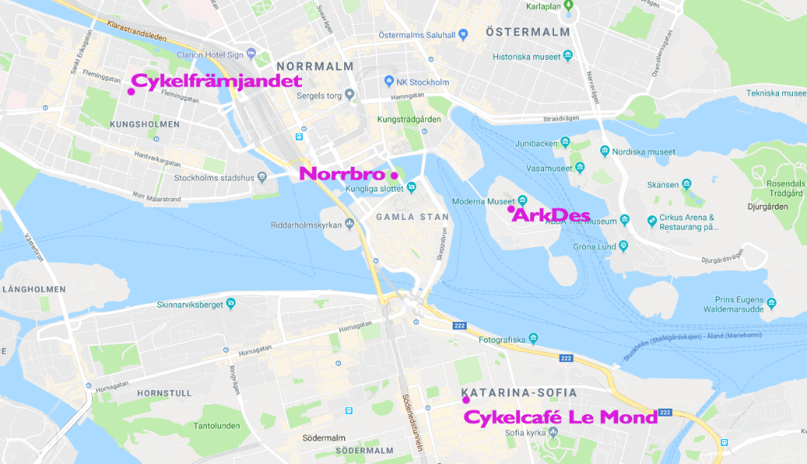

September 16 – Cykelkarnevalen: festivities and parade through a car-free city center, Norrbro
https://cykelkarneval.com
14:00-15:30 bike parade
17:00-20:00 Networking event at the Cykelfrämjandet Office

September 17 – Workshop day with local planners, ArkDes National Centre for Architecture and Design
9:00-17:00 Workshops

September 18 – Project meeting day, Cykelcafé Le Mond
9:00-12:00 Meeting

TRAVEL TO STOCKHOLM:
Stockholm is served by three airports: Bromma is the closest to the city center, Arlanda is the largest and about 40 minutes outside of town by car, but is accessible by fast train (Arlanda Express) and regular bus service (Flygbussarna). Skavsta airport is more than an hour south of town.

Stockholm also has regular ferry service to many Baltic ports, with centrally located ferry terminals.

ACCOMMODATION
There are a wide variety of hotels and hostels to suit your needs in Stockholm. The classic hostel AF Chapman has a location that is hard to beat just a stone’s throw from our meeting location on Monday:

https://www.svenskaturistforeningen.se/anlaggningar/stf-stockholmaf-chapman-skeppsholmen-vandrarhem-huset/

If you would like to stay at the AF Chapman, please book your room as soon as possible since it is popular and booked quickly.

MEALS
All lunches will be provided as well as dinner on the 17th. Please notify the organizers about any special diets while registering for the meeting. Please register by August 30th on the following site:

https://goo.gl/forms/2FECRVEVu5CTVdDX2

CONTACT PERSON IN STOCKHOLM
In case you need help, please contact Hans Stoops +46 73 969 5013

